User Login Process:

First hit API /users/login like below and the hit execute to get a JWT Bearer token

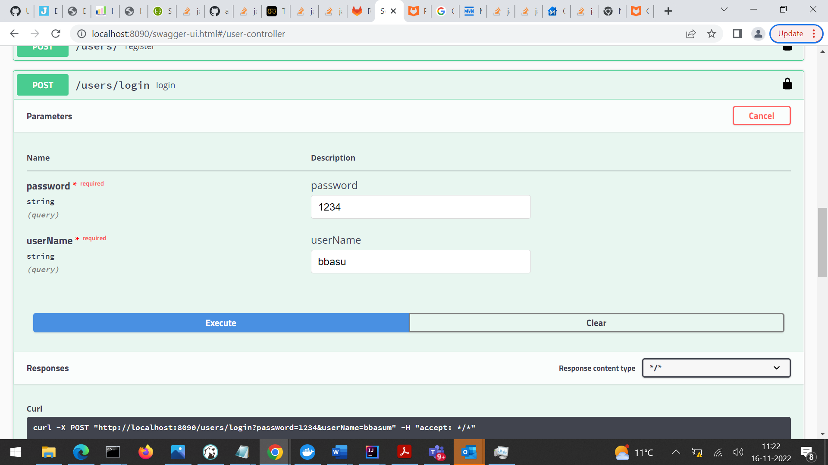

Copy the JWT as shown below and hit Authorize

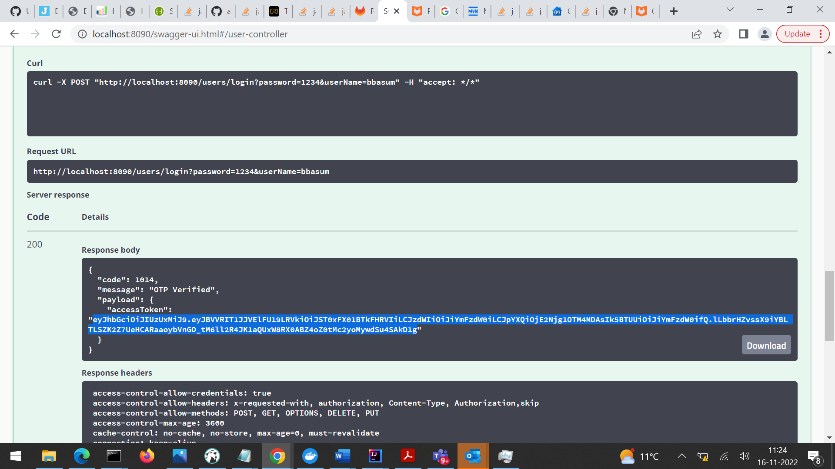

Then you will get a screen like below add Bearer and the paste the JWT from previous step and click Authorize.

